# CS335 assignment

# Created on April 30 2020

# Table of Contents

1.0. Page 1

2.0. Page 2

3.0. Page 3

# 1.0. Page 1

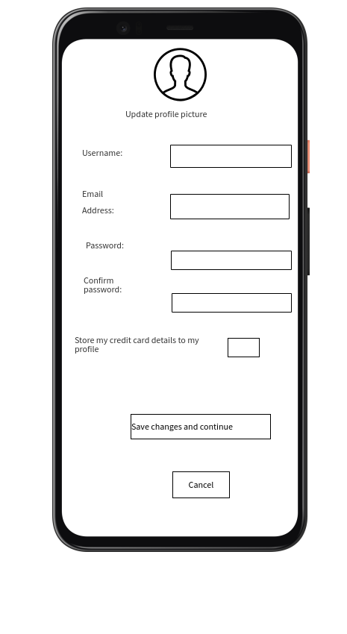

# 2.0. Page 2

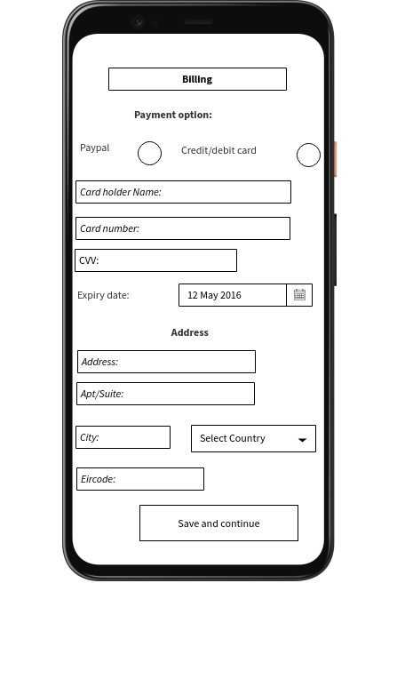

# 3.0. Page 3

